**PROJECT REPORT**

VISUALIZATION TOOL FOR ELECTRIC VEHICLE CHARGE AND RANGE ANALYSIS

1. Introduction
   1. ***Overview***

A visualization tool for electric vehicle (EV) charge and range analysis would be an application that provides visual representations of data related to an EV's charge and range. This tool could help EV owners or fleet managers to better understand and optimize their vehicle usage by providing insights into charging patterns, range limitations, and energy consumption.

The visualization tool could include features such as:

* Charging history: A graph or chart that displays the charging history of the vehicle, including the amount of energy consumed during each charge, the time and date of each charge, and the charging speed.
* Range estimator: A tool that estimates the remaining range of the EV based on its current charge level and past energy consumption.
* Charging station locator: A map that shows the location of nearby charging stations, including their availability and charging speed.
* Energy usage breakdown: A breakdown of the energy usage of the vehicle, including how much energy was consumed by driving, climate control, and other features.
* Customizable alerts: Alerts that can be customized to notify the user when their vehicle reaches a certain charge level, when a charging station becomes available, or when the vehicle is running low on range.

Overall, a visualization tool for EV charge and range analysis could help EV owners and fleet managers make more informed decisions about how to use and maintain their vehicles, leading to increased efficiency, cost savings, and a more sustainable transportation system.

* 1. ***Purpose***

The purpose of a visualization tool for electric vehicle charge and range analysis is to provide a user-friendly and interactive way to understand the charging and range behavior of an electric vehicle. Such a tool can help electric vehicle owners and fleet managers make informed decisions about charging and route planning, leading to more efficient and cost-effective use of electric vehicles.

By using data from the vehicle's onboard sensors and charging infrastructure, a visualization tool can display information such as the vehicle's battery level, charging speed, and estimated range. The tool can also incorporate real-time data on traffic conditions, weather, and other factors that can affect an electric vehicle's range.

The primary benefits of a visualization tool for electric vehicle charge and range analysis include:

* Improved awareness and understanding of an electric vehicle's charging and range behavior
* More efficient route planning and charging, leading to cost savings and reduced downtime
* Better management of electric vehicle fleets, including optimization of charging infrastructure and vehicle allocation
* Increased confidence in the viability of electric vehicles as a practical mode of transportation.

2 Problem definition and design thinking.

***2.1 Empathy map***

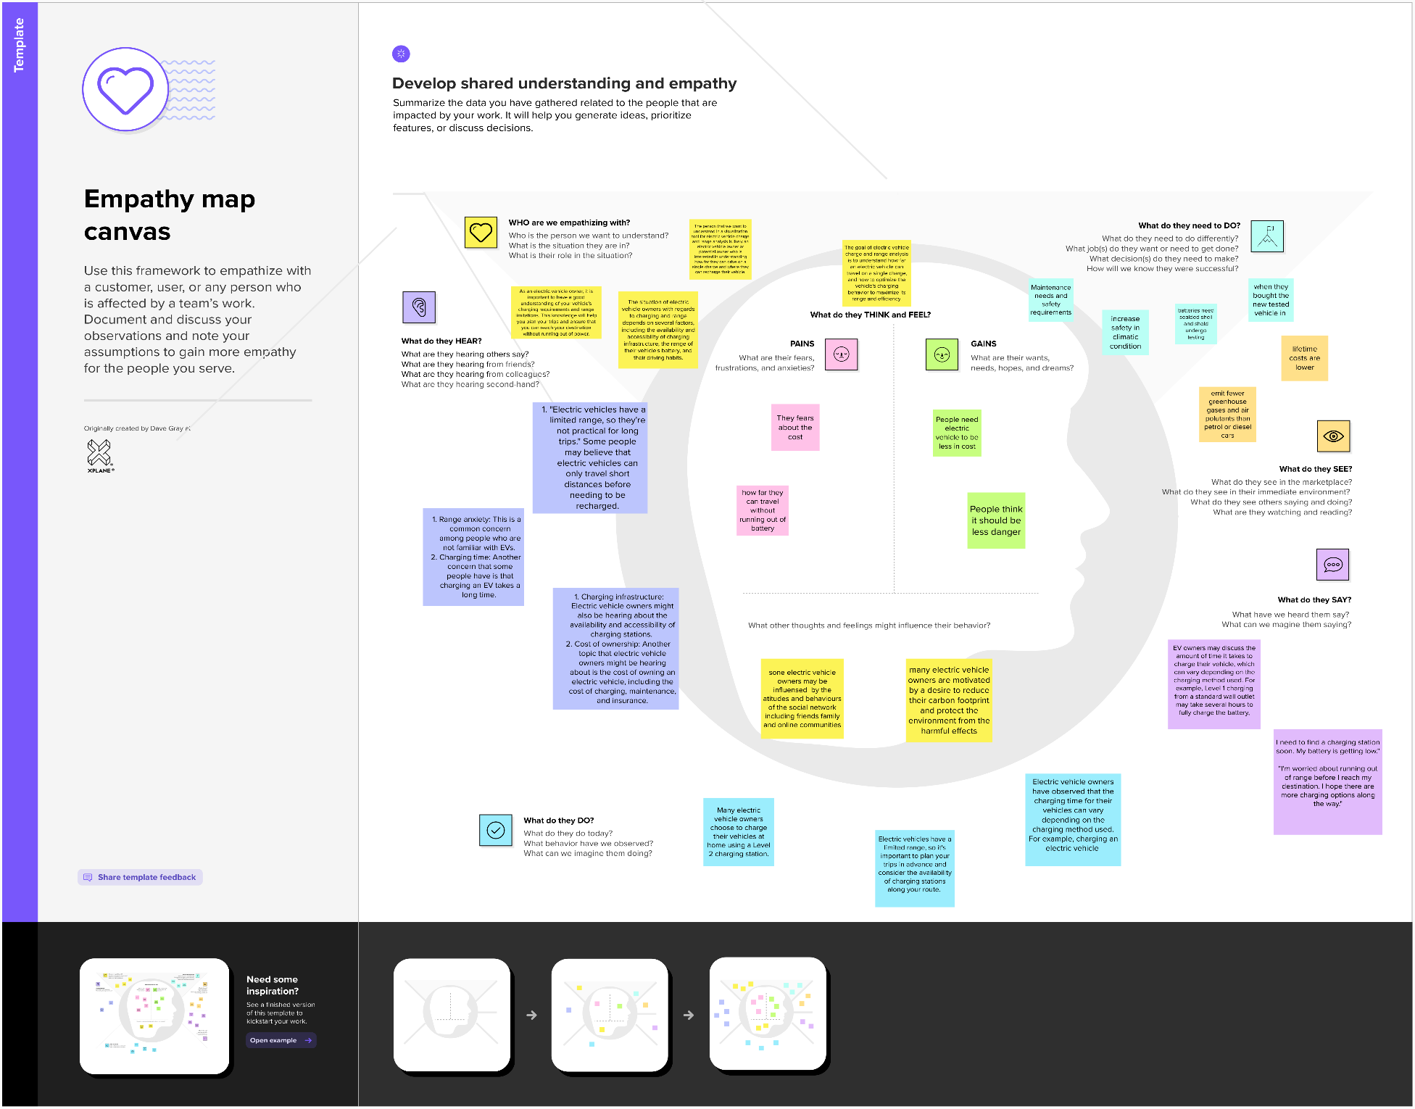

***2.2 Ideation and Brainstorming Map***

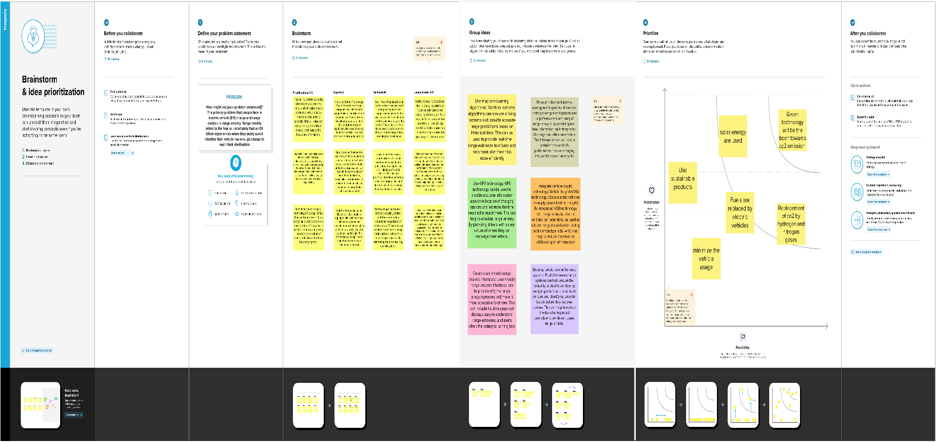

3 Result

***Activity & Screenshot***

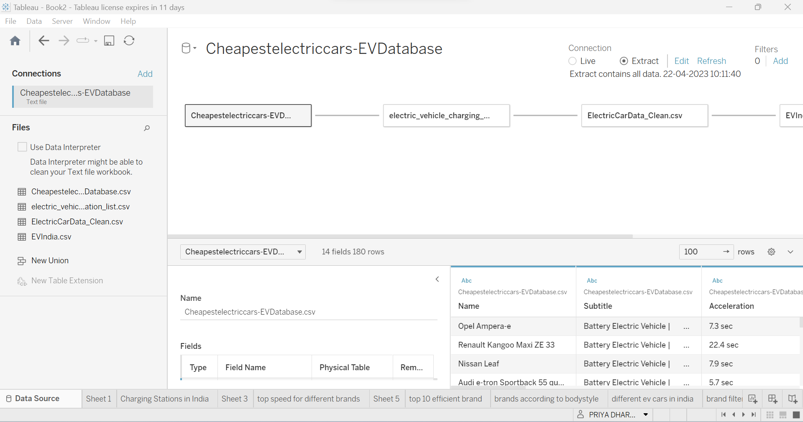

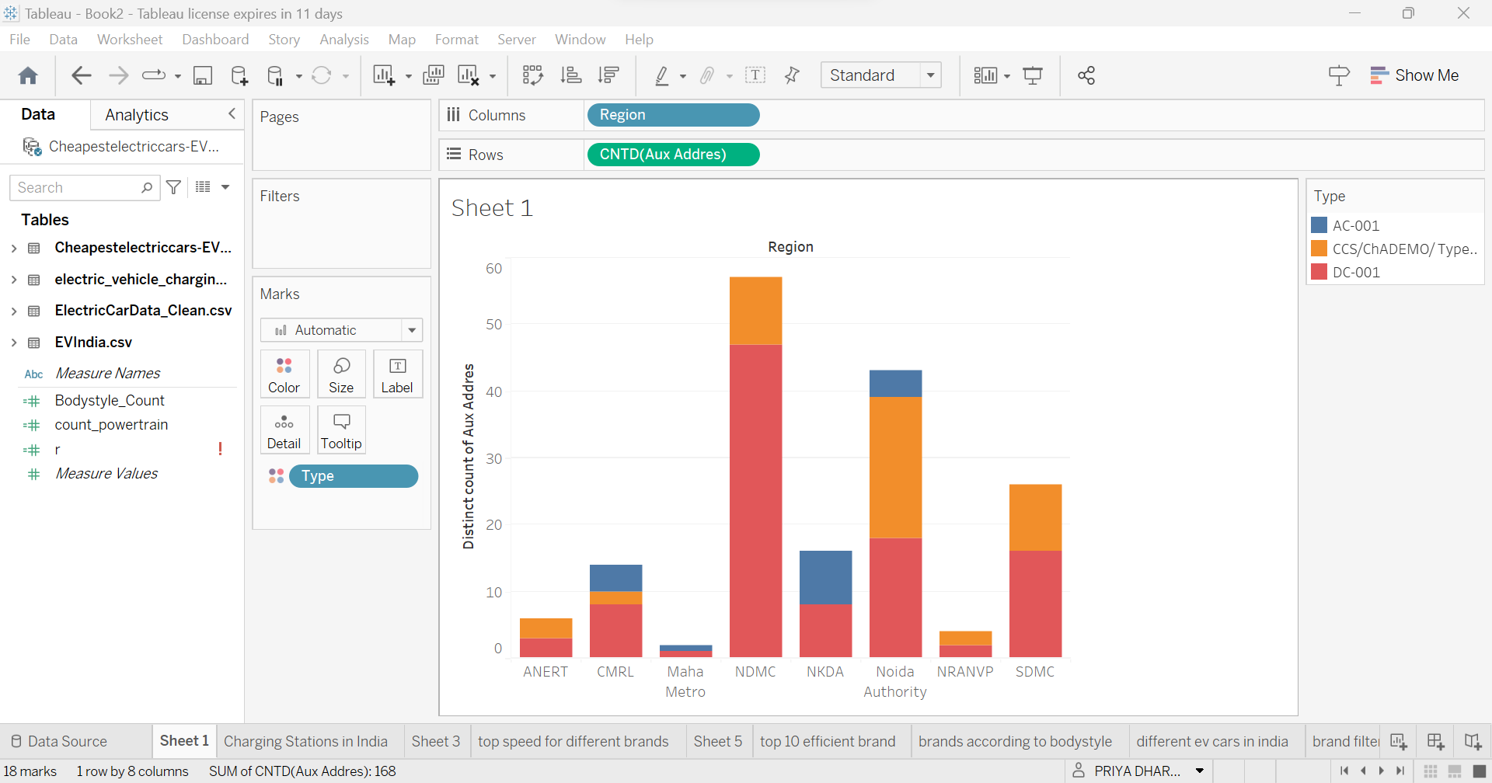

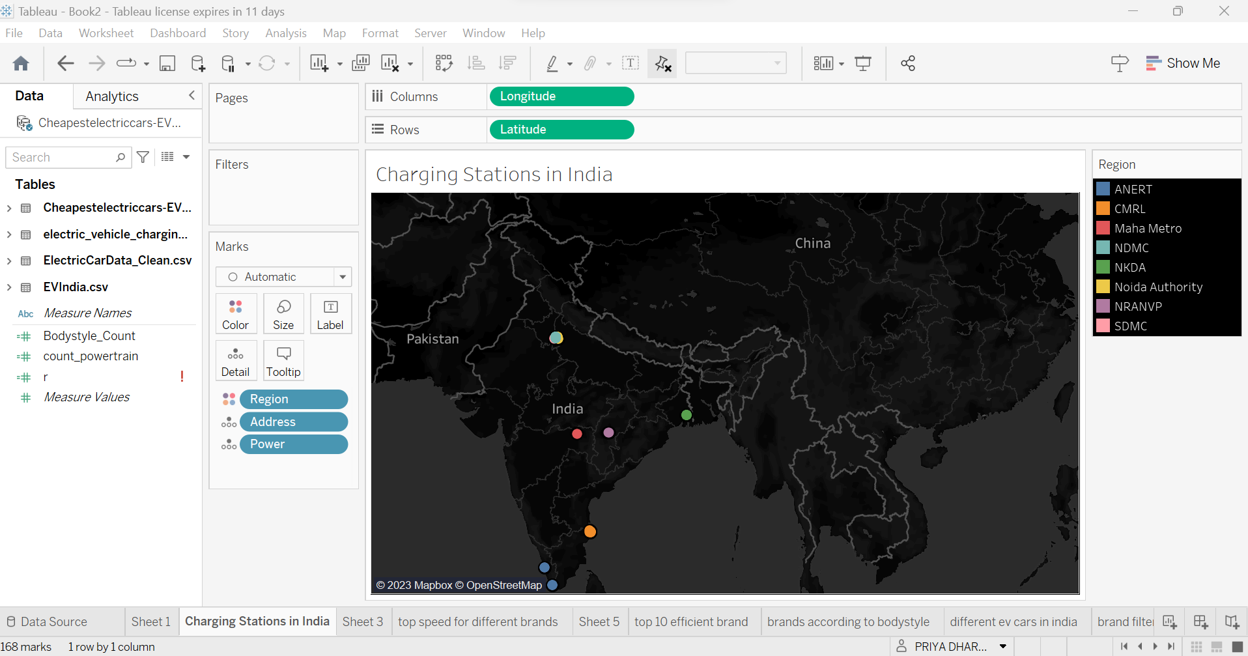

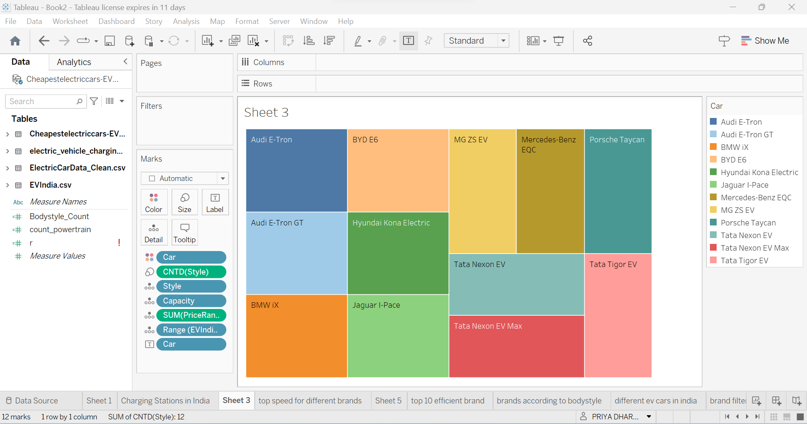

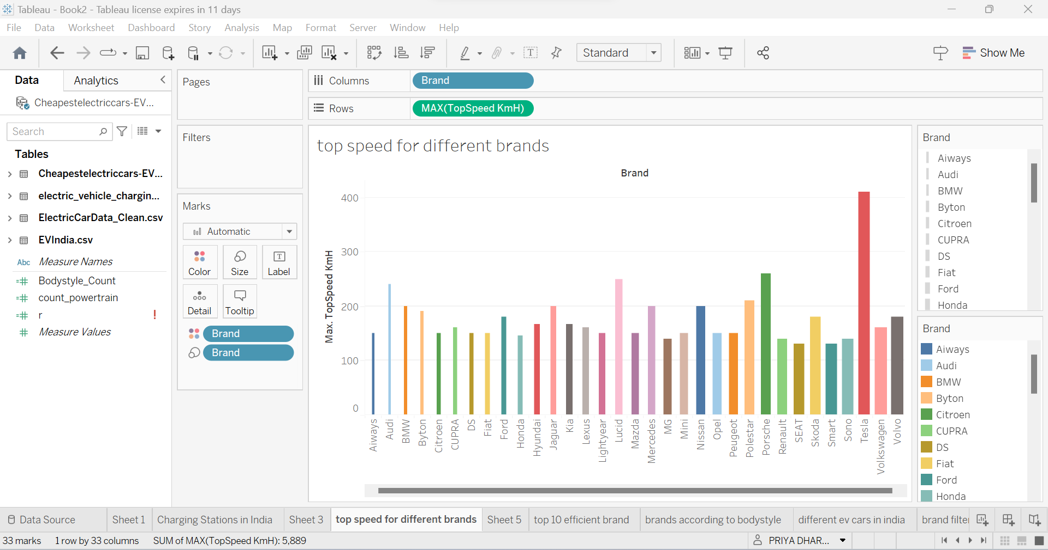

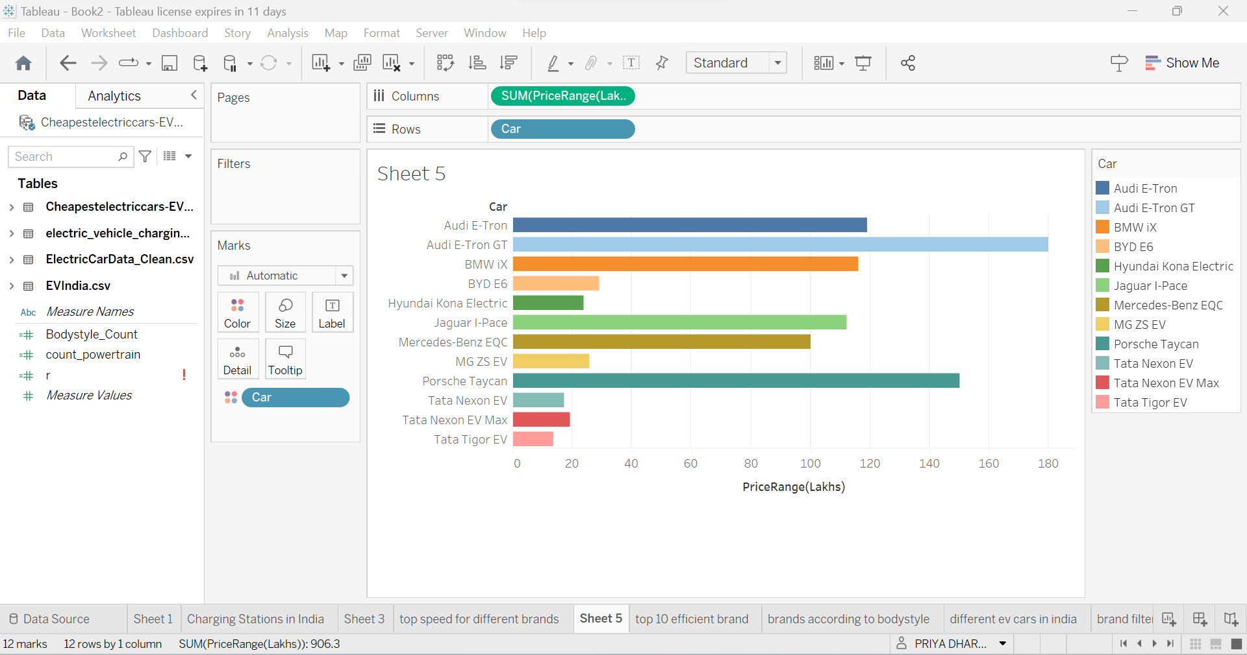

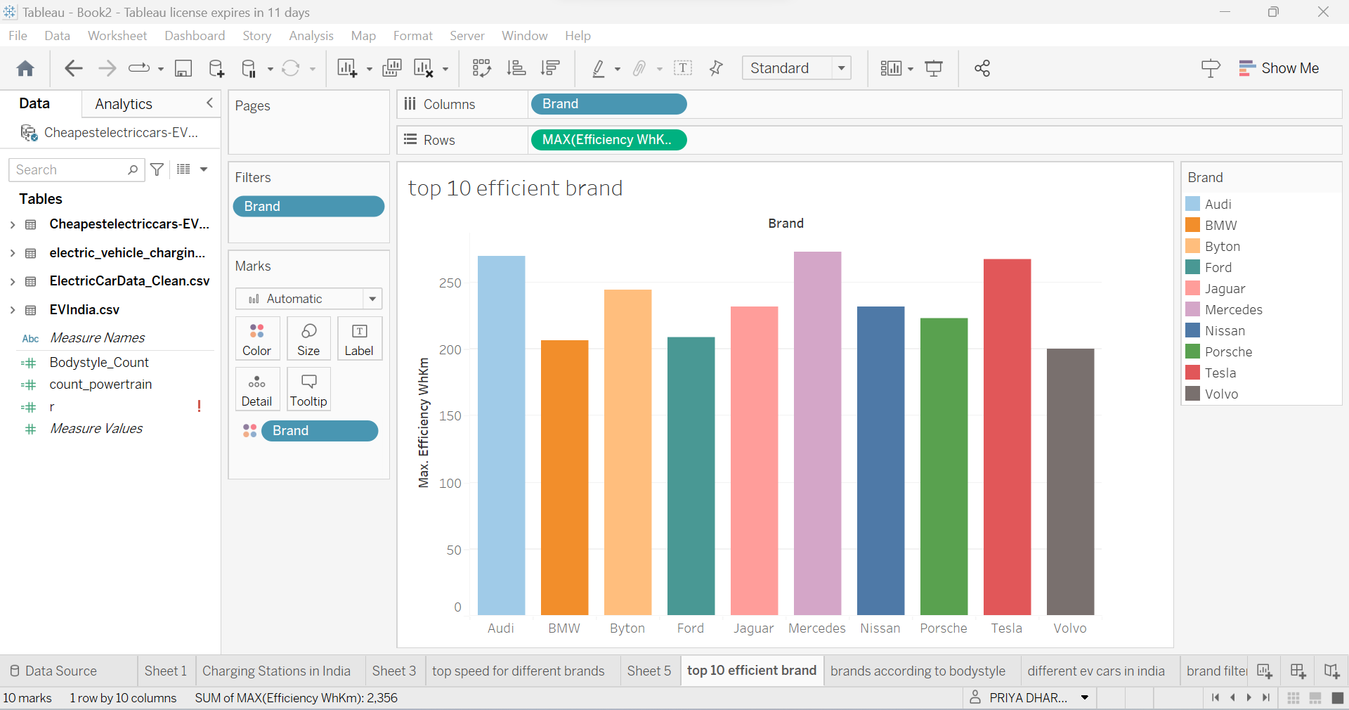

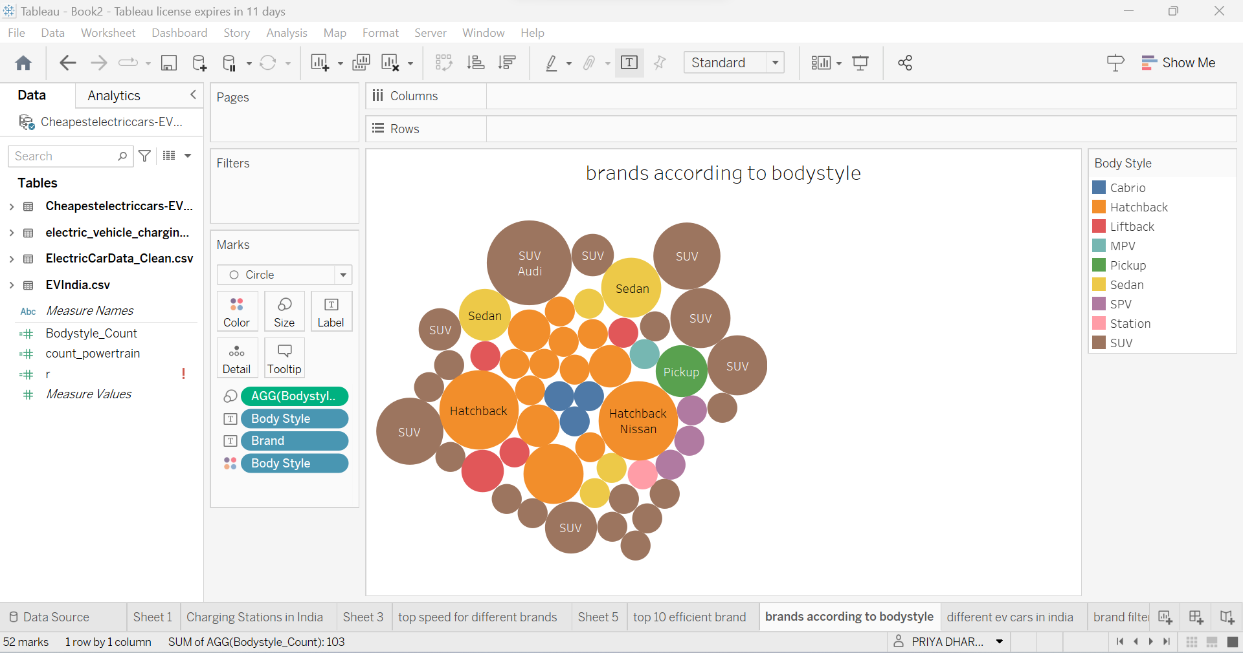

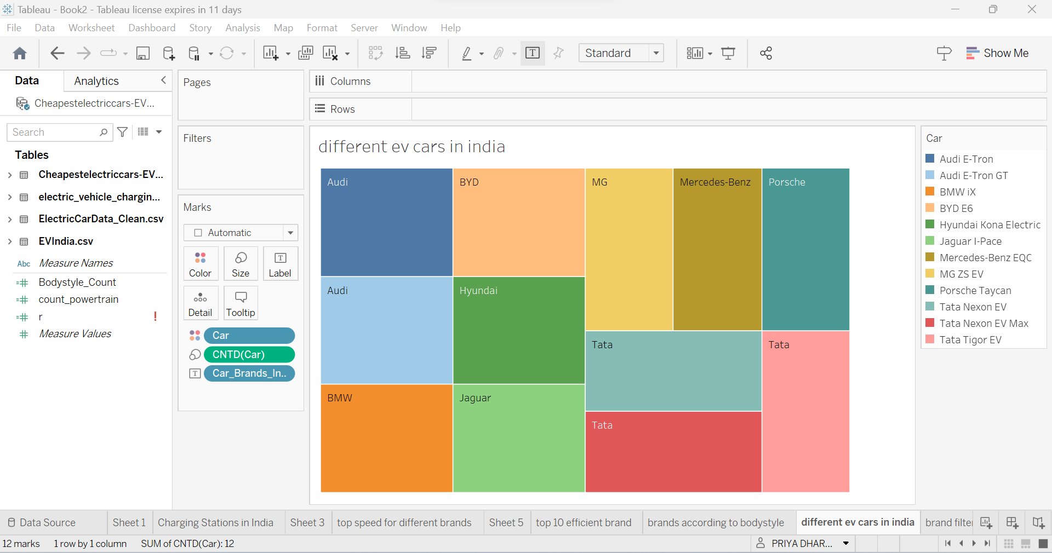

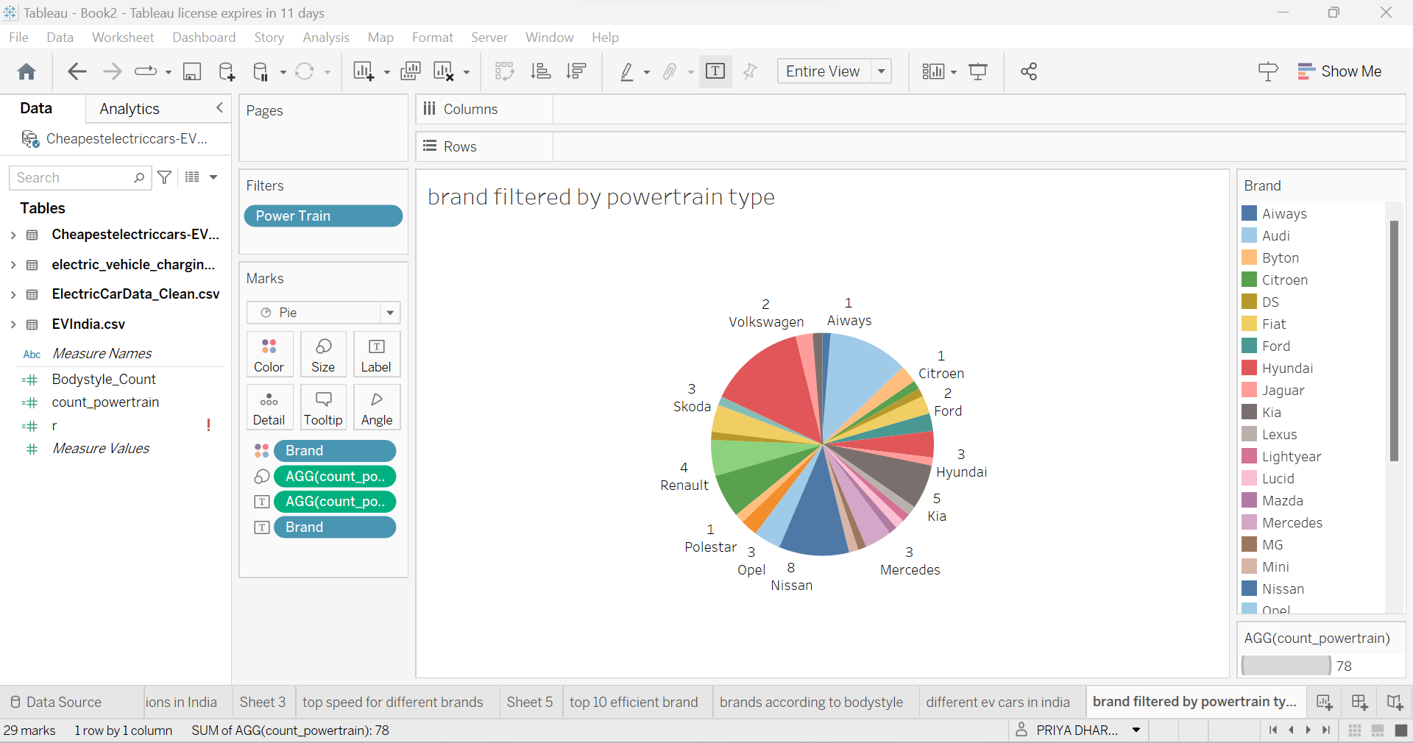





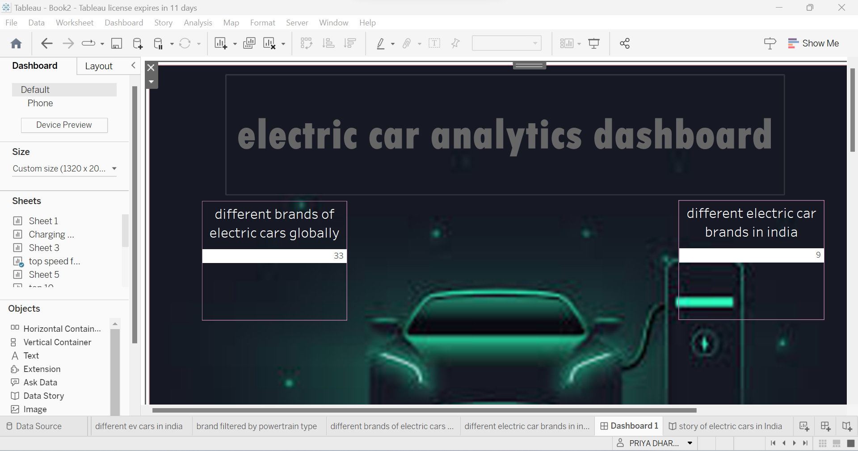

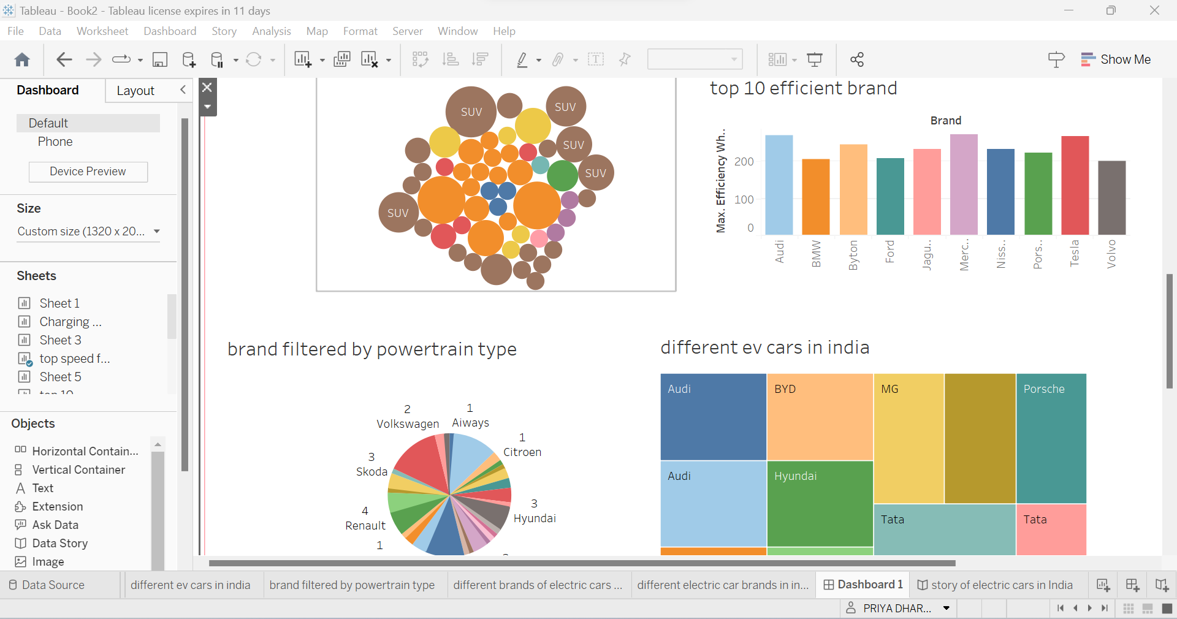

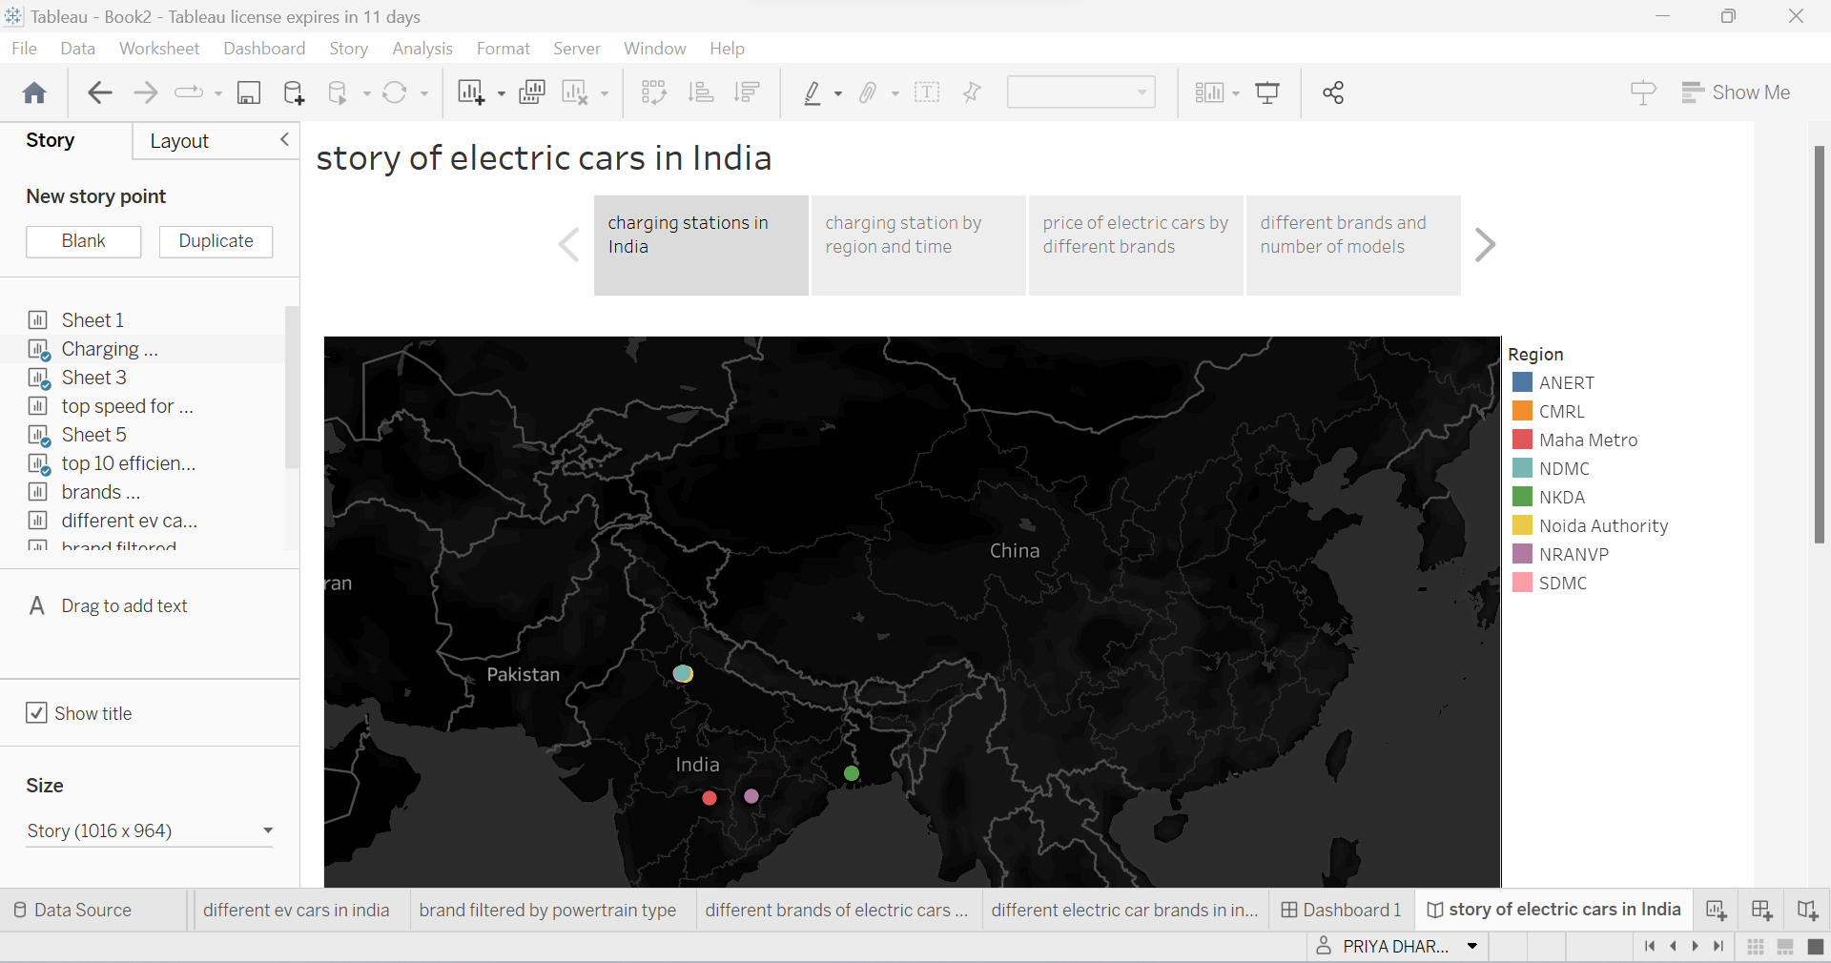

4 Trailhead Profile Public URL

Team Lead - <https://trailblazer.me/id/priyadharshana>

Team Member 1 – <https://trailblazer.me/id/gayathrij28>

Team Member 2 – <https://trailblazer.me/id/santhosh0403>

Team Member 3 - <https://trailblazer.me/id/jenaterubbini1102>

5 Advantage and Disadvantage

***Several advantages, including :***

Visualizations can be a powerful tool for analyzing and understanding complex data, and this is especially true in the context of electric vehicle (EV) charge and range analysis. Here are some of the advantages of using a visualization tool for this purpose:

* Better understanding of charge and range: Visualizations can provide a clear and intuitive way to understand how much charge is remaining in an EV battery and how far the vehicle can travel before needing to be recharged. This can help drivers plan their trips more effectively and make better decisions about when and where to charge their vehicles.
* Identification of charging patterns: Visualization tools can help identify patterns in charging behavior, such as the times of day when a vehicle is most frequently charged, or how long it typically takes to fully charge the battery. This information can be used to optimize charging strategies and reduce the overall cost of charging.
* Comparison of charging options: By visualizing data on the cost and availability of different charging options, a visualization tool can help EV owners choose the most cost-effective and convenient option for their needs.
* Prediction of range: Visualization tools can use data on driving habits, weather conditions, and other factors to predict the range of an EV under different conditions. This can help drivers plan their routes and ensure that they have enough charge to reach their destination.
* Improved communication: Visualizations can be a powerful tool for communicating information about EV charging and range to a wide range of audiences, including policymakers, EV manufacturers, and the general public. By presenting data in a clear and compelling way, visualization tools can help promote the adoption of EVs and support the development of a more sustainable transportation system.

***Potential disadvantages, including:***

While a visualization tool for electric vehicle charge and range analysis can be useful, there are also some disadvantages to consider, including:

* Data accuracy: The accuracy of the data used in the visualization tool can greatly impact its usefulness. If the data is not accurate, the tool may provide inaccurate or misleading results.
* Limited scope: The tool may be limited in scope, only providing information about a specific electric vehicle model or charging infrastructure. This can limit its usefulness for individuals who own different types of electric vehicles or who travel to different locations.
* Technical proficiency: Using a visualization tool may require a certain level of technical proficiency or familiarity with the tool, which can be a barrier for some individuals.
* Cost: Some visualization tools may require a subscription or purchase, which can be costly for individuals or organizations with limited resources.
* Reliance on internet connectivity: The tool may require a reliable internet connection, which can be a problem in areas with poor connectivity or during power outages.
* Privacy concerns: The use of a visualization tool may require the sharing of personal data, which can raise privacy concerns for some individuals.
* Environmental impact: The production and use of the tool may have environmental impacts, such as increased energy consumption or carbon emissions.

6 Applications

***Some of the most effective and widely used methods include***

A visualization tool for electric vehicle charge and range analysis can have numerous applications, some of which are:

* Fleet Management: Electric vehicle fleet managers can use the tool to analyze the charging and range patterns of their vehicles. This can help them optimize their charging infrastructure, predict charging times, and plan routes that maximize the vehicles' range.
* Individual Vehicle Owners: Electric vehicle owners can use the tool to analyze their vehicle's charging and range patterns. This can help them plan their trips better, optimize their charging habits, and identify any issues with their vehicle's battery or charging system
* Charging Station Operators: Charging station operators can use the tool to analyze the usage patterns of their stations. This can help them optimize the location and capacity of their stations, predict demand, and offer customized charging plans to their customers.
* City Planners: City planners can use the tool to analyze the charging and range patterns of electric vehicles in their city. This can help them plan the location and capacity of charging infrastructure, optimize traffic flow, and reduce congestion.
* Energy Companies: Energy companies can use the tool to analyze the impact of electric vehicle charging on their grid. This can help them optimize their energy supply, predict demand, and offer customized charging plans to their customers.

Overall, a visualization tool for electric vehicle charge and range analysis can help improve the efficiency and sustainability of electric vehicle operations, benefitting individual users, businesses, and society as a whole.

Top of Form

Bottom of Form

7 Conclusion

In conclusion, the development of a visualization tool for electric vehicle charge and range analysis is an essential step towards enhancing the adoption of electric vehicles. The tool provides a simple and interactive interface that enables electric vehicle owners to track and analyze their charging patterns and driving habits.

The visualization tool utilizes various data sources, such as the vehicle's battery status, charging history, and driving behavior, to provide users with real-time updates on the remaining range, estimated time to charge, and other critical information. It also allows users to compare their driving and charging habits with others, identify opportunities for improvement, and optimize their usage of the electric vehicle.

Overall, the visualization tool is a valuable tool for electric vehicle owners and stakeholders, as it provides a comprehensive understanding of the charging and range aspects of electric vehicles. By leveraging this tool, users can make informed decisions and maximize the benefits of owning an electric vehicle.

8 Future Scope

The future scope of a visualization tool for electric vehicle charge and range analysis is quite promising. As electric vehicles become increasingly popular and more affordable, there is a growing need for tools that help users understand the range and charging requirements of their vehicles.

One potential future development is the integration of real-time data from electric vehicle charging stations and vehicle telemetry systems, allowing users to monitor their vehicle's charging and range in real-time. This could help drivers make informed decisions about when and where to charge their vehicles, and how far they can safely travel on a single charge.

Another potential development is the incorporation of machine learning algorithms and predictive analytics, allowing the tool to learn from user data and make personalized recommendations for charging and range management. For example, the tool could analyze a user's driving patterns and recommend the most efficient charging strategies based on those patterns.

As electric vehicle technology continues to evolve, the visualization tool could also incorporate new features and functionality, such as the ability to analyze the impact of weather and road conditions on range and charging requirements, or the integration of renewable energy sources like solar and wind power.

Overall, the future scope of a visualization tool for electric vehicle charge and range analysis is quite broad, and will likely continue to expand as electric vehicle technology continues to evolve and become more widespread.